YUKTI - National Innovation on Repository
- Title (20 Words Max):
SEPSIS PREDICTION USING WIRELESS SENSORS AND RANDOM FOREST ALGORITHM
- Developed as part of: Mini Project
- Sector / Domain: Medical IoT.
- Innovation Type: This project showcases product innovation by integrating IoT and machine learning for early sepsis detection. It combines real-time sensor data with predictive analytics in a localized system, enabling efficient health monitoring. By merging hardware, software, and AI, it delivers a cost-effective, accessible solution, enhancing early diagnosis and personalized care in healthcare technology.

- Choose the Financial Year, during the Idea PoC/Innovation on Developed:
2024-2025
- Define the problem and its relevance to today's market / society / industry need (Max: 100 Words):
Sepsis, a life-threatening condition, often goes undetected until it's too late, causing high mortality rates globally. Early detection and timely intervention are crucial but challenging due to the lack of accessible and cost-effective monitoring systems. This project addresses this gap by integrating IoT and AI to provide real-time health monitoring and sepsis risk prediction. In today's healthcare landscape, where personalized, preventive care is essential, this solution offers a scalable and affordable approach, catering to hospitals, home care, and resource-limited settings. It meets the increasing demand for efficient, technology-driven health solutions that save lives and reduce the burden on healthcare systems.
- Describe the Solution on / Proposed /Developed (Max: 100 Words):
The solution integrates IoT, sensors, and AI to monitor vital signs like heart rate, SpO2, respiratory rate, and temperature in real-time using an ESP32 microcontroller. Data is sent to a local app via HTTP, combined with clinical inputs, and analyzed by a machine learning model to predict sepsis risk. A Flask-based application provides an intuitive interface for data input, real-time monitoring, and result display. This system ensures early detection and timely intervention, offering an affordable, scalable, and accessible healthcare solution for hospitals, home care, and resource-constrained environments.

- Uniqueness and Distinctive Features (100 Words):
This solution is unique in its seamless integration of IoT, real-time monitoring, and AI-driven predictions for sepsis detection. Unlike traditional systems, it combines sensor data and clinical inputs into a single framework for accurate risk assessment. The use of affordable hardware like ESP32 and sensors ensures cost-effectiveness, while the locally hosted Flask application provides data privacy and accessibility without reliance on cloud infrastructure. Its real-time monitoring, easy deployment, and adaptability to resource-constrained environments make it distinct. This innovation bridges preventive healthcare and personalized medicine, catering to diverse needs in hospitals, home care, and underserved communities.

- Competitor Differentiation (100 Words):
This solution differentiates itself from competitors by combining affordability, real-time monitoring, and localized AI-powered predictions for sepsis detection. Unlike expensive, cloud-dependent healthcare systems, it uses low-cost hardware like the ESP32 and sensors while maintaining data privacy through a locally hosted application. Competitors often focus solely on advanced clinical setups or remote monitoring without predictive analytics, whereas this system integrates sensor data with clinical inputs for precise risk assessment. Its scalability, adaptability to resource-limited settings, and focus on preventive care provide a unique edge, making it suitable for both hospitals and home care, especially in underserved regions.

- IP or Patent Component:
Market The project has potential for Intellectual Property (IP) or patentable components in the following areas:
- Integrated System Design: The unique combination of IoT devices, sensors, and AI algorithms for real-time sepsis prediction.
- Data Processing Framework: Novel methods for merging sensor data and clinical inputs into a single predictive model.
- Custom Machine Learning Model: Specific features and architecture tailored for sepsis risk assessment.
- Local App Workflow: Innovative implementation of a localized, privacy-focused health monitoring and prediction system.
These components, individually or collectively, could be patented to protect the system's originality and usability in healthcare.

- Innovation Grant/Seed Fund Support: Not yet received.
- Recognitions (National/International): No
- Commercialization Status: Not yet commercialized.
- Pre-Incubation/Incubation Support: No pre-incubation/incubation support received yet.
- Utility / Value Proposition (100 Words):
This solution provides significant value by offering an affordable, real-time sepsis detection system, enhancing early diagnosis and intervention. By integrating IoT, sensor data, and AI-driven predictive analytics, it allows healthcare providers to monitor critical health metrics like heart rate, temperature, and SpO2 in real-time, improving patient outcomes. The system’s cost-effectiveness, ease of deployment, and adaptability make it accessible for resource-constrained settings, including hospitals and home care environments. It empowers healthcare professionals with accurate, actionable insights, reduces the burden on healthcare systems, and ultimately saves lives by identifying sepsis risks before they escalate to life-threatening levels.
.
- Scalability (100 Words):
This solution is highly scalable, designed to cater to a wide range of healthcare environments. Its low-cost hardware and localized deployment make it suitable for resource-limited settings, while its modular architecture allows for easy integration with existing healthcare systems. The system can be expanded to monitor additional health parameters and support more advanced machine learning models as technology evolves. It can be deployed in hospitals, clinics, and home care environments, with the potential to scale across regions, especially in underserved areas. Its flexibility allows for future updates, ensuring long-term applicability as healthcare needs grow and change.
- Economic Sustainability (100 Words):
The solution offers economic sustainability through its low-cost hardware, which includes affordable sensors and the ESP32 microcontroller, reducing the initial investment required for healthcare facilities. Its localized nature eliminates the need for expensive cloud services, lowering ongoing operational costs. By providing early detection of sepsis, it can prevent costly complications, hospital readmissions, and intensive care unit admissions, ultimately reducing healthcare expenses. The system’s scalability ensures it can be deployed in diverse settings, including resource-limited areas, making it accessible to a broader population. These factors combine to create a cost-effective, long-term solution that benefits both healthcare providers and patients.
- Environmental Sustainability (100 Words):
The solution promotes environmental sustainability by using energy-efficient, low-power components such as the ESP32 microcontroller and compact sensors. The system’s localized deployment minimizes the need for data centers and reduces the carbon footprint associated with cloud computing. Additionally, the use of affordable, widely available components ensures that the system is adaptable to various regions, reducing the need for extensive manufacturing and transportation of specialized hardware. The focus on resource efficiency extends to the overall design, which can be deployed in resource-constrained environments, contributing to a more sustainable healthcare approach by reducing electronic waste and unnecessary infrastructure demands.

- Photograph/Document Upload :
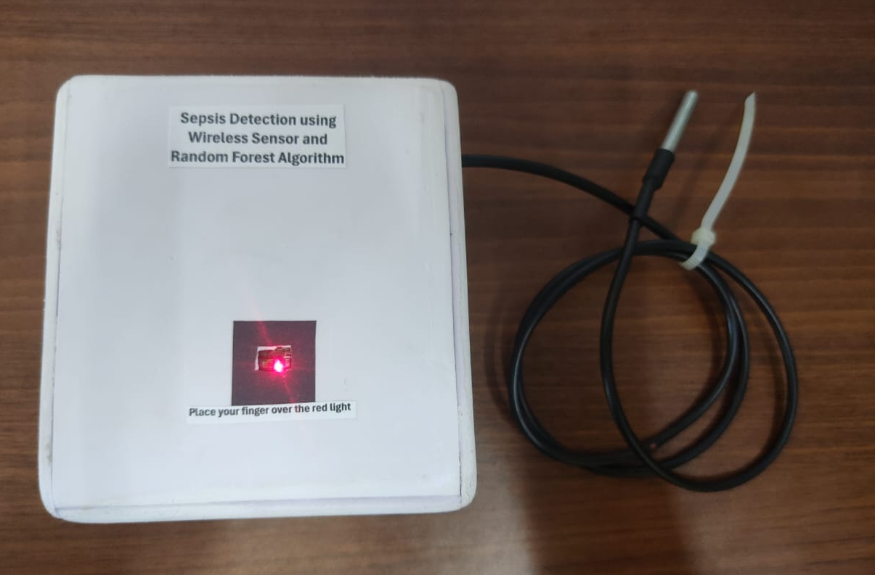

Figure 1. Hardware Setup
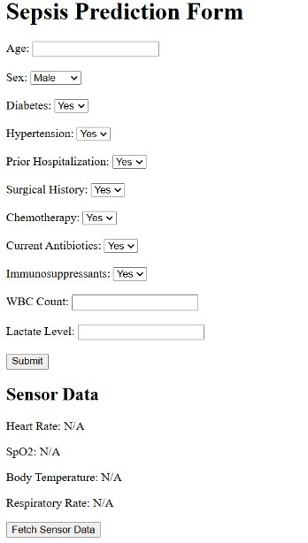

Figure 2. Sepsis Prediction webpage

BY TEAM
ANJELO GIGI
AKASH K P
ABHISHEK M V
ANKITHA K V

